# E-commerce sql queries and outputs

* Using tables in E-Commerce database

***use ecommerce;***

***select * from fact_table;***

***select * from item_dim;***

***select * from store_dim;***

***select * from trans_dim;***

* Displaying the division, district, upazila from store_dim where division is SYLHET" and district MAULVIBAZAR

***select division, district, upazila from store_dim where division= "SYLHET" and district = "MAULVIBAZAR";***

* Displaying information of stores only in "RANGPUR","SYLHET","KHULNA","CHITTAGONG"

***select * from store_dim where division in ("RANGPUR","SYLHET","KHULNA","CHITTAGONG");***

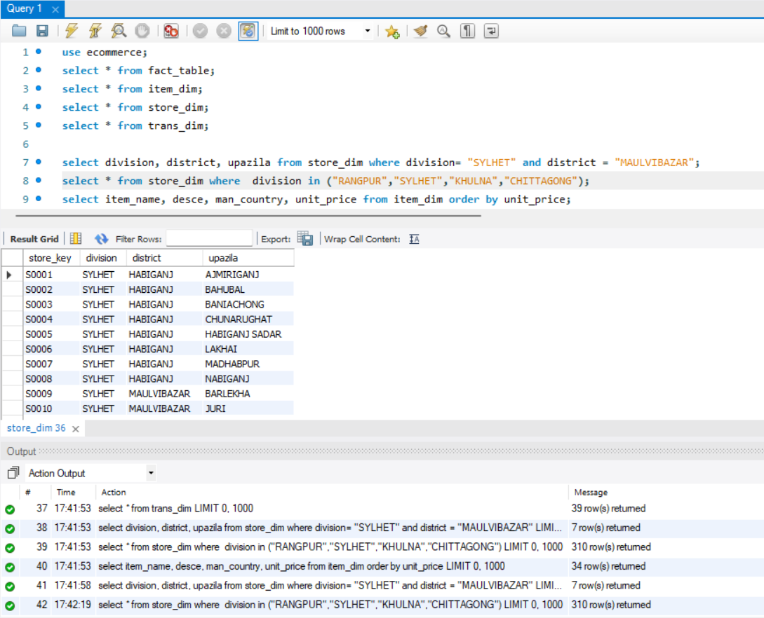

* Diplaying the information in the order od unit_price

***select item_name, desce, man_country, unit_price from item dim order by unit_price;***

_

* Displaying the disticts where tge total_price is above 500

***select store_key ,district***

***from store_dim***

***where store_key***

***in (***

***select sum(store_key)***

***from fact_table***

***where total_price >=500***

***);***

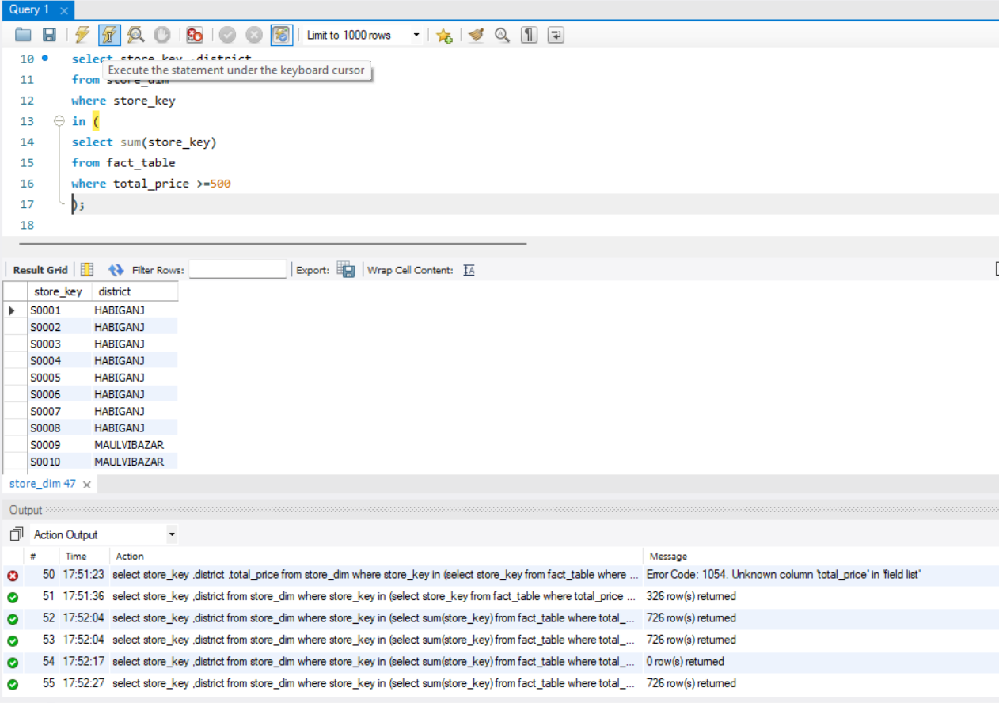

* Displaying the count of countries based the beverages sold

***select desce, count(man_country)***

***from item_dim***

***group by desce;***

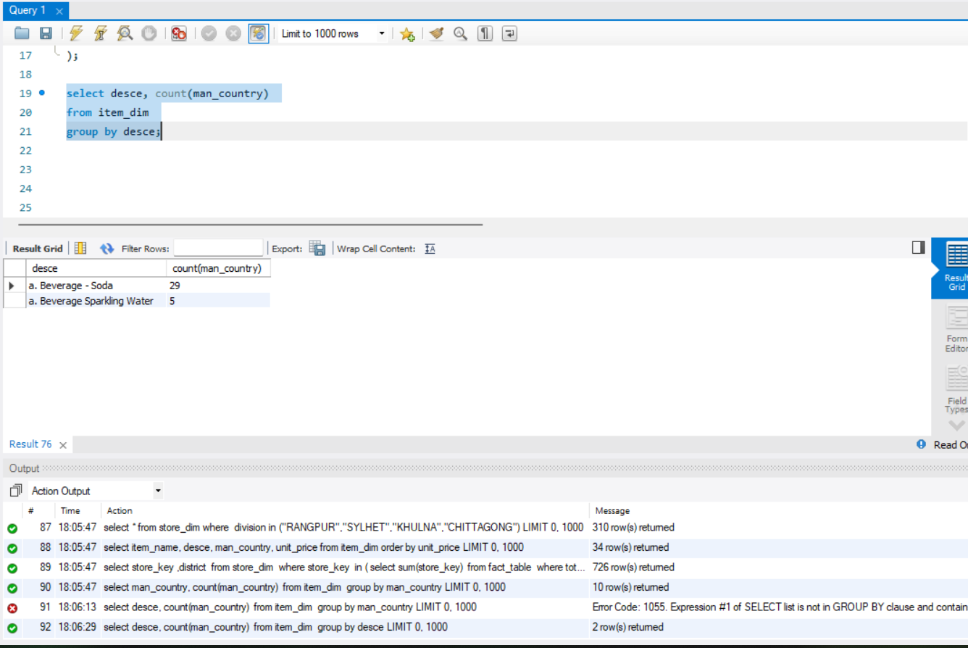

* Creating a view

***create view item_detail as***

***select fact_table.item_key ,item_dim.item_name,item_dim.desce,item_dim.supplier, fact_table.quantity,fact_table.unit,fact_table.total_price***

***from fact_table join item_dim on fact_table.item_key = item_dim.item_key ;***

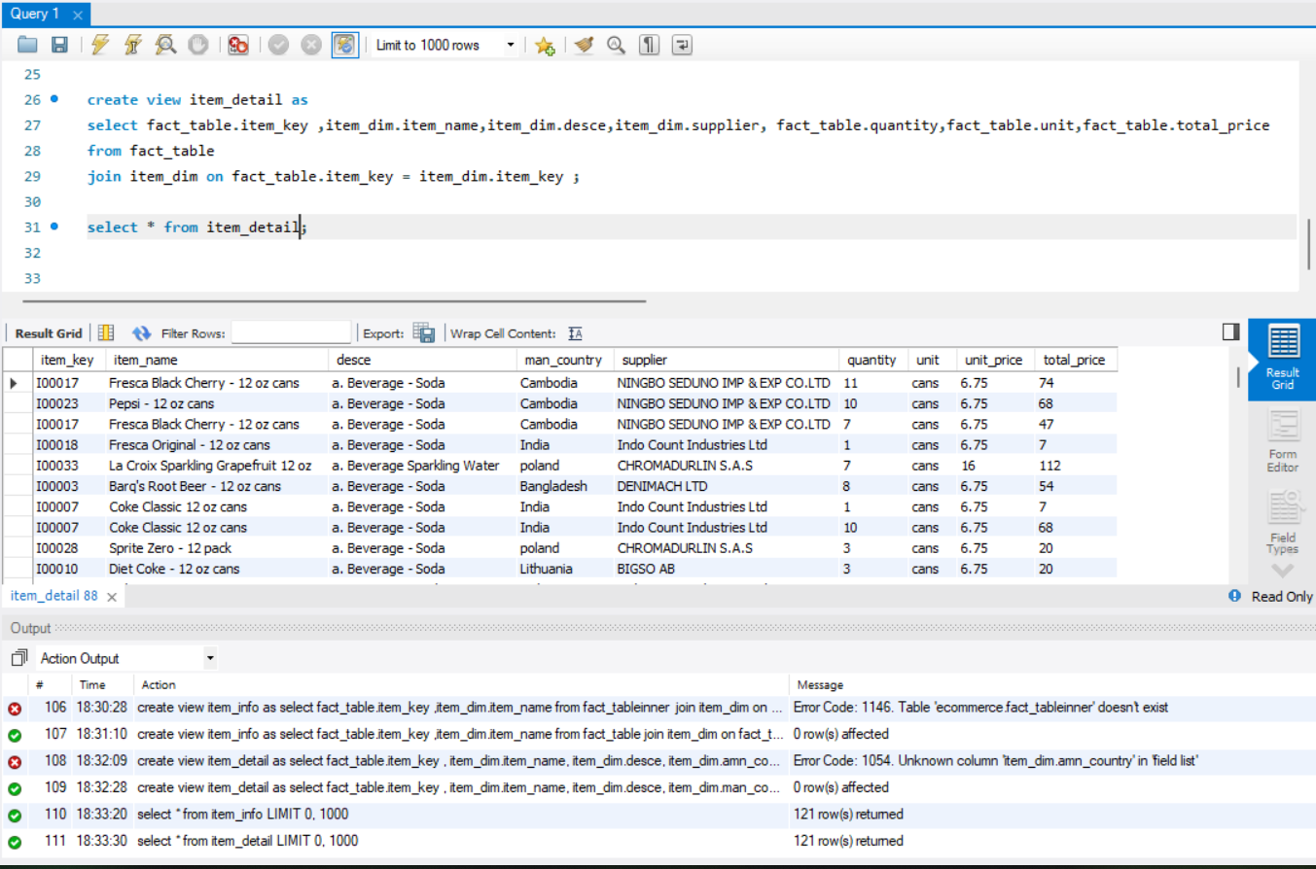

* Finding the total quantity sold and the total price

***select man_country,sum(quantity) "total quantity sold",sum(total_price) "toatl price recieved " from item_detail group by man_country;***

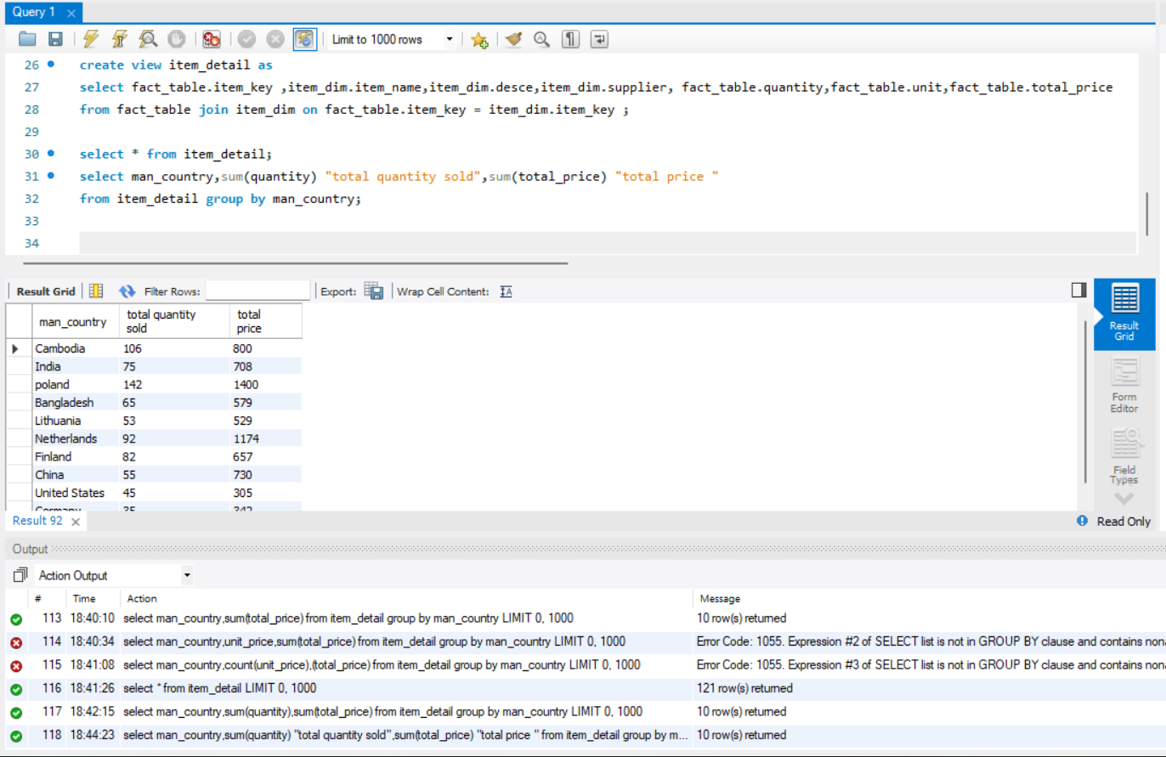

* Joining 3 tables for better understanding

***select fact_table.item_key,item_dim.item_name,fact_table.quantity,fact_table.total_price,fact_table.payment_key,trans_dim.trans_type,trans_dim.bank_name***

***from fact_table***

***join item_dim on fact_table.item_key= item_dim.item_key***

***join trans_dim on fact_table.payment_key = trans_dim.payment_key***

***;***

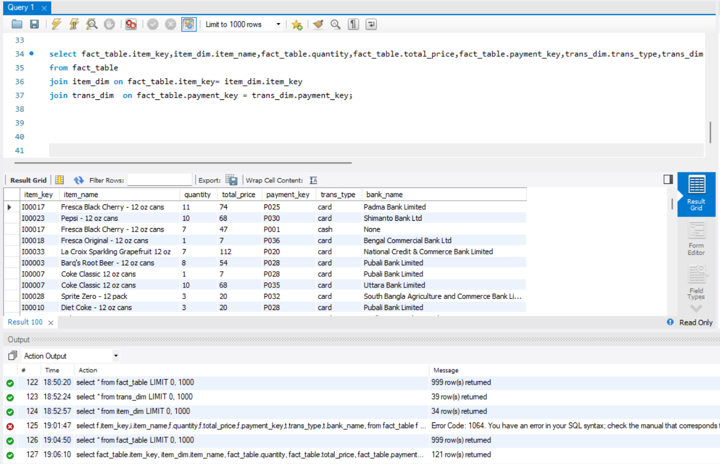

* Creating index

***create INDEX idx_payment_item on fact_table(item_name(10), quantity(10));***

***explain***

***select fact_table.item_key,item_dim.item_name,fact_table.quantity,fact_table.total_price,fact_table.payment_key,trans_dim.trans_type,trans_dim.bank_name***

***from fact_table***

***join item_dim on fact_table.item_key= item_dim.item_key***

***join trans_dim on fact_table.payment_key = trans_dim.payment_key***

***;***

